**MCEN 4026: Manufacturing Processes & Systems**

Statistical Process Control Lab (SPC)

Due 11:59pm Wednesday 3/20 (Lab 011 and 012)

Due 11:59pm Friday 3/22 (Lab 013 and 014)

*In this lab you will be collecting measurements, creating X-bar and R-charts and evaluating process capability for the Al cylinders measured in the Inspection GD&T Lab.*

**_________________________________________________________________________________________________________**

**Part 1 – Analyze the Al pellet data (measured as part of Task 2 of the GD&T Lab)**

Download the RawData.xls file from Canvas that includes data measured from Task 2 (Al pellet height) of the GD&T lab, using both the height gauge and the dial indicator. Envision that you have 42 days of data with 10 random samples for each of two different secondary processes: measurement with height gauge and measurement with dial indicator. Note that the original process involves cutting down Al rod stock into shorter, nominally 1” tall cylinders.

Using either MATLAB or Excel – use the data provided to calculate X-bar and R-charts for the two distinct processes: measurement with (1) height gauge and (2) dial indicator. Follow the steps below.

1. What are *m* and *n* for this dataset?

*Verify your dataset grouping with the TAs before creating your charts.*

1. Create X-bar and R- Control Charts for both sets of processes.

*Be sure to clearly label the values of UCL and LCL on all charts and provide descriptive axes titles and chart titles. You should have 4 charts total when you are complete.*

1. What are the USL and LSL for this product/process?

*Recall the original drawing, provided on Canvas, and the specification for the height of the Al cylinders (see snippet below in Fig. 1)*

1. Calculate Cp and Cpk values, assuming an acceptable process is running at 3-sigma. Also assume that your process is running in control to start:
   1. Calculate Cp and Cpk using sigma as calculated from the measurement population (42*10 = 420 measurements) using the Height Gauge and using the Dial Indicator (2 sets of Cp and Cpk values)
      1. Cp =
      2. CP
   2. Calculate Cp and Cpk using sigma as calculated from the formula $σ={\overline{R}}/{d_{2}}$ (where $d_{2}$ is a constant taken from the Shrewhart Control Chart Constants table 36.2), for measurements using the Height Gauge and measurements using the Dial Indicator (2 more sets of Cp and Cpk values).
   3. Compare the values for Cp and Cpk calculated in (a) and (b) for the same processes (height gauge to height gauge and dial indicator to dial indicator). Which value of sigma should you use in your calculations? Why? *Hint: Either way of calculating sigma is acceptable but comes with assumptions about the sample data’s relationship to the overall population. Explain those assumptions.*
2. If you find the two processes are not *capable,* adjust your USL and LSL as needed for either process to make the Cpk greater than 1. *Note the new values of Cp & Cpk corresponding to your new values of USL and LSL.*

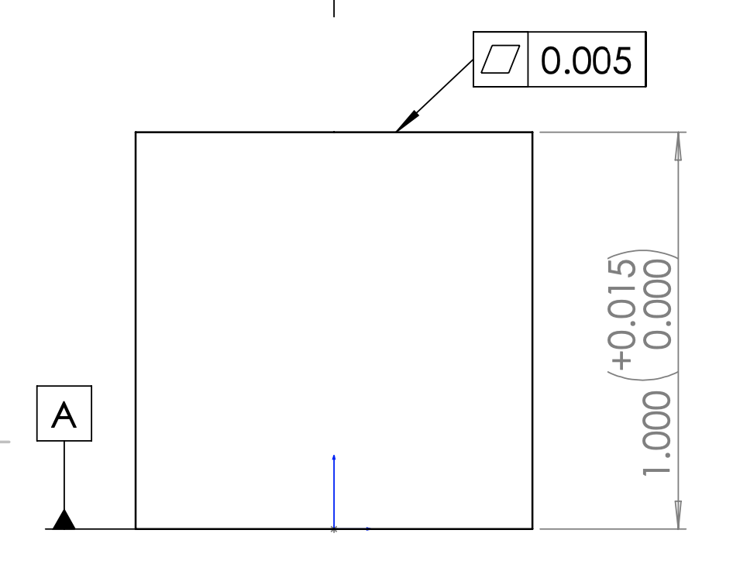

Figure 1: Al cylinder height specification (dimensions in inches)

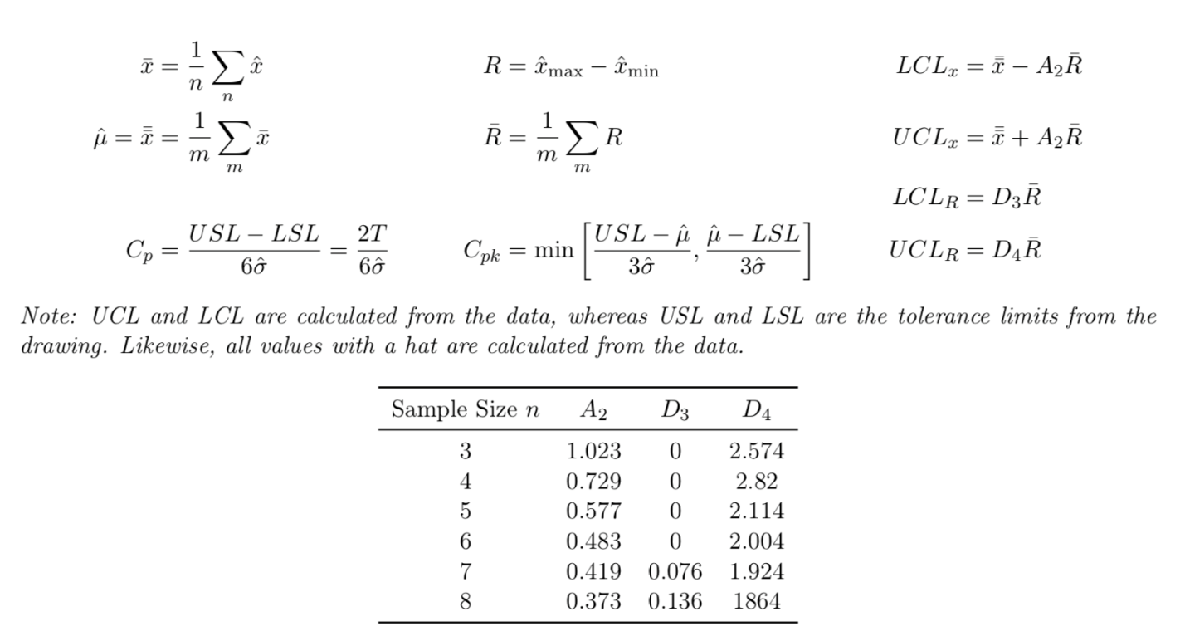

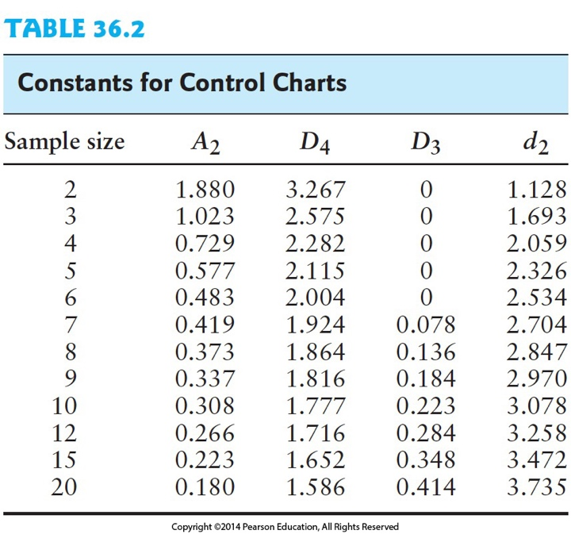

**Part 2 – Consider questions below.**

1) Based on the given data, is the measurement process in control? Answer separately for the two processes:

a) Height Gauge

b) Dial Indicator

2) How did you change the USL and LSL for any of the processes that are not capable?

3) Which value of sigma (calculated from the dataset in 4a or from the formula in 4b) did you use for your Cp and Cpk calculations? Why?

4) How would the proposed change(s) to the spec limits affect the functionality of the part or the measurement technique?

5) What other changes could you make to the part or process to make sure all measurements are capable (both Cp and Cpk)?

**Online submission (one pdf per team) should include:**

1. Values for *m & n* (for both processes)
   * Height and Dial:
     + m = 42
     + n =10
2. X-bar and R-charts for both processes (using either Matlab or Excel)
   * *Height LCL & UCL:*
     + *X*
       - UCL =
       - LCL =
     + R
       - UCL
       - LCL
3. Cp and Cpk:
   * Calculated using both versions of sigma for both processes (4 sets total) with original LSL & USL
   * *Height Cp & Cpk:*
     + *X_Sigma:*
       - Cp = 0.403081658612923
       - Cpk = -0.238866190894013
     + R_Sigma:
       - Cp =
       - Cpk =
   * *Dial Cp & Cpk:*
     + *X_Sigma:*
       - Cp = 0.389890518394643
       - Cpk = -0.224063397083943
     + R_Sigma:
       - Cp =
       - Cpk =
   * Calculated after modifying LSL and USL. Report revised values for LSL & USL and updated Cp and Cpk given choice of sigma.
4. Questions to answers above

**Grading Distribution for Lab**

|  |  |
| --- | --- |
| 1. Values for *m & n* (for both processes) | 2 pts |
| 1. X-bar and R-charts for both processes, using either Matlab or Excel    1. Charts include descriptive titles and axes labels    2. *Appropriate LCL & UCL* are shown on all charts | 16 pts  (4 per chart) |
| 1. Cp and Cpk:    1. Calculated using both versions of sigma for both processes (4 sets total, 1 pt each, with original LSL & USL)    2. Calculated after modifying LSL and USL. Report revised values for LSL & USL (4 pts) and updated Cp and Cpk (4 pts) given choice of sigma for both processes. | 12 pts |
| 1. Follow Up Questions (4 pts each) | 20 pts |

|  |  |
| --- | --- |
| **Total** | **50 pts** |